# Lab 14: Optimization using Response Surface Methods (Chapter 7)

## Objectives

* Use the method of steepest ascent to find new center values to be used in optimization
* Optimize your significant terms by using steepest ascent along with DOE methods you already know
* Analyze your model using central composite designs in JMP

From last week, you’ll remember that our summary of design of experiments (for creating your own data, rather than using existing data) was as follows. This week we add on the final steps, optimizing the significant variables in order to maximize our output and get our highest possible yield.

***Creating your DOE***

1. Create a DOE in JMP, either full factorial if we have <3 factors (lab 12) or fractional factorial if we have >3 factors (lab 13)
2. Obtain your experimental data by:
   1. Translating your coded values outputted by JMP into real values



where x0 = center point (average between maximum and minimum value)

xc = coded value (will be -1, 0, or 1)

λ = the portion of the range you are considering, usually between

5%-10% (.05-.1)

Rx = the range for that parameter (maximum value minus

minimum value)

* 1. Running those real values as experiments (or, in this class, in a website simulator)
  2. Paste your output values into the Y column in JMP

***Finding significant parameters***

1. Screen for significant effects using stepwise regression (lab 13) and create your model
2. Analyze your model given the outputs from JMP (lab 12)

This week, we’ll learn the next steps: using the method of steepest ascent to find new center values, optimization, and checking your model.

## Finding the Direction of Steepest Ascent

Once a linear model is constructed and the β values are calculated with at least one β being significant, a direction can be found in which higher production values should exist. This Direction of Steepest Ascent (DoSA) is equal to the gradient of the linear model function. Basically, what we are doing is finding the direction where the values will increase the most, so we can optimize efficiently, and then moving along this line until we have optimized our parameters in order to give us a max

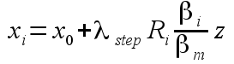

xi is the value for a particular factor at some location z along the vector where z is a scalar multiplied by the range of factor i times some λ step size times the scaled parameter estimate βi/βm. z typically takes integer values unless it is desired to run a point in between.

It generally a good idea to plot the production values as you move along the vector so you can see when a new maximum has been reached.

Once this new maximum is found, a new linear model needs to be fit to the response surface centered at this new center point and the new x0. If the linear model has any significant term, then the process continues where a new DoSA is found and new optimum obtained. When the linear model fails and you have eliminated all significant factors, it is then time to move on to the second order response model.

## Checking Your Model Using Second Order Response Models

Now that you’ve optimized all of your (previously) significant factors, we want to check our model to see if the parameters are, indeed, optimized. We’ll do these using a Central Composite Design (CCD) in JMP. To set up a CCD and analyze a second order model in JMP, choose DOE > Response Surface Design from the menu or JMP starter page. Add the appropriate number of factors and rename them if you wish. Hit the continue button. Now select the option named 'Central Composite Design'. It should be the run with 2 center points. Hit the continue button. Change the axial value to be rotatable by clicking on the appropriate radio button. Now hit the make table button.

The table generated by this function is similar to the table returned by the screening design. You should use the same procedure to translate the table into real values to be executed in the 'pilot plant'. Once the results are copied back into the JMP table, select Analyze > Fit Model from the menu. Everything should already be populated correctly so you can simply hit 'Run Model'.

The quickest way to see if you have a good model is by looking at the bottom of the output at the prediction profiler plots. If you see obviously concave down curves with the maximum easily visible for each factor, then you should have a good model to predict the optimum running conditions. This will occur when the quadratic terms are negative in value and significant.

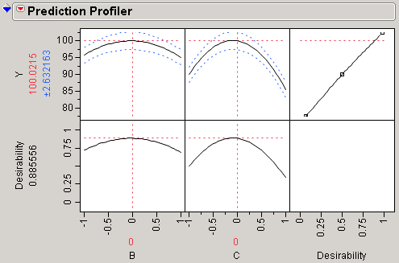

Next, expand the 'Response Surface' box to see the predicted critical value. If all factors had a negative quadratic term, then the critical value will be a maximum. If all quadratic terms are positive, then the critical value will be a minimum. In any mixed case, the critical value will be a saddle point indicating that no optimum was found. You may run into saddle points in the lab or project; in this case, you need to move further along a vector when you perform DoSA calculations to get yourself out of the saddle point.

Assuming that JMP does offer a maximum point, consider the magnitude of the critical value points. If they are within the range of the α values, then the model can be interpolated to determine this point and it most likely does offer a optimum value. But if the critical values are outside of the α values, then the model is being extrapolated and cannot be as easily trusted. Thus, using CCD may not necessarily confirm that your model is optimized, but instead that further optimization may be warranted.

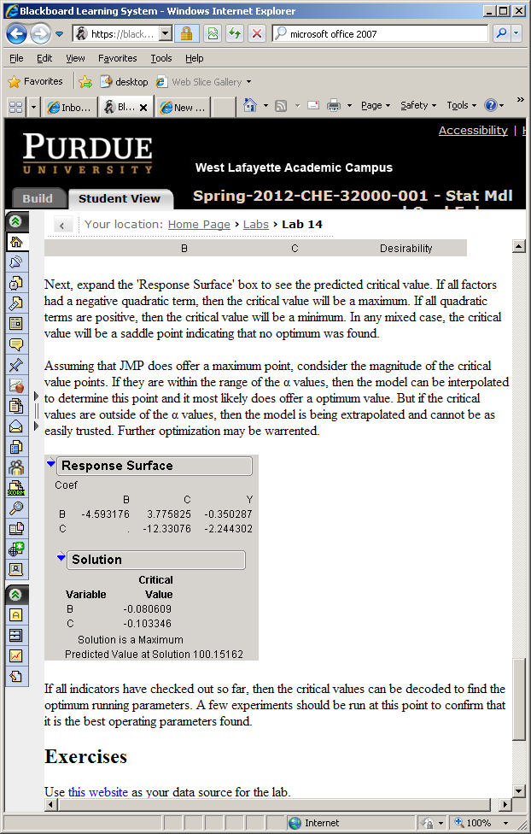

## Summary of DOE

Now, we can complete our study of DOE (in terms of what we’ve learned in this class, and what needs to be done to successfully complete the project) and summarize it as follows:

***Creating your DOE***

1. Create a DOE in JMP, either full factorial if we have <3 factors (lab 12) or fractional factorial if we have >3 factors (lab 13)
2. Obtain your experimental data by:
   1. Translating your coded values outputted by JMP into real values



where x0 = center point (average between maximum and minimum value)

xc = coded value (will be -1, 0, or 1)

λ = the portion of the range you are considering, usually between

5%-10% (.05-.1)

Rx = the range for that parameter (maximum value minus

minimum value)

* 1. Running those real values as experiments (or, in this class, in a website simulator)
  2. Paste your output values into the Y column in JMP

***Finding significant parameters***

1. Screen for significant effects using stepwise regression (lab 13) and create your model
2. Analyze your model given the outputs from JMP (lab 12)

***Using the method of steepest ascent to find new center values (lab 14)***

1. You will move incrementally in the method of steepest descent by finding new xi’s that depend on your beta values found in your JMP model. You only have to do step changes for significant parameters; the non-significant parameters can stay at whatever values corresponded to your optimum found in step 2.



where x0 = center point used in step 2

λstep = your step size, usually between .05-.1

Ri = the range for that parameter (maximum value minus minimum value)

βi = the slope value for that parameter

βm = the maximum slope value for all significant parameters

z = your step (an integer starting at 1)

1. Plug these new values into the website simulator to obtain your Y value.
2. Repeat steps 5-6 until you have maximized your Y. This may be easiest to see by plotting Y vs. z and stopping after you have reached a maximum Y.

***Optimization (lab 14)***

1. Use your values from the last step as your center points for your next screening of factors and decode your data as in step 2.
2. Refit a linear model from this data, including ONLY significant terms.
3. You should now find that at least one of y our previously significant terms is now NOT significant (the P-value > alpha). This means that you have optimized that value. You must now repeat steps 5-7 again for any terms that are still significant.

***Checking your model (lab 14)***

1. Once you have optimized every term (and you have cut out all significant terms from the model), you can check your model using response surface design.
   1. Choose DOE > Response Surface Design
   2. Include significant terms
   3. Adjust these coded values to real values
   4. If your parameter has been optimized, the prediction profiles should be parabolas.



1. If your CCD model checks out, you are done. You may want to run a couple more runs to confirm that your yield is maximized. If your CCD does not confirm an optimized model, you have to go back and re-optimize parameters.

## Lab 14 Exercises

Use the simulator (<https://engineering.purdue.edu/~che320/labs/lab13/reactor/>) as your data source for the lab.

* Using the two significant factors from last week (B, C), find the linear model parameters using the data from the screening if you still have it. Otherwise, run new data to build the model.
* Find the DoSA and set up the formulas in Excel to find new points along the vector. Run those points to find a new maximum output.
* Try to fit another linear model around the best point from the last step
* Decided if another DoSA is needed. If so, repeat the DoSA and linear model experiments.
* Run a CCD and try to locate the optimum running conditions.
* Decode and run the optimum point to verify it does give the best values.

Feel free to repeat this exercise until you are very comfortable with the procedure. Try using different λ values in the factorial experiments and stepping along the DoSA. You may have to allow for a higher p-value in determining which parameters are chagned in the DoSA.

You should be able to do the screening and optimization for this lab in 50 runs or less.